SESSION-13

TASK-1
Create a decision table for a Flipkart-style coupon validation system where a coupon is only valid if: (1) the user is logged in, (2) the cart value is above ₹500, and (3) the coupon has not expired. Show all possible combinations and the resulting action (accept/reject).
ANSWER:
Conditions:
- User is logged in.
- Cart value is above ₹500.
- Coupon is not expired.
Y = Yes/True, N = No/False
Rule | Logged In? | Cart > ₹500? | Coupon Valid? | Action
R1 | Y | Y | Y | ✅ Accept
R2 | Y | Y | N | ❌ Reject
R3 | Y | N | Y | ❌ Reject
R4 | Y | N | N | ❌ Reject
R5 | N | Y | Y | ❌ Reject
R6 | N | Y | N | ❌ Reject
R7 | N | N | Y | ❌ Reject
R8 | N | N | N | ❌ Reject
Conclusion
The coupon is accepted only when all three conditions are true. If even one condition fails, the coupon is rejected.
TASK-2
Draw a state transition diagram for a Paytm login feature that locks the account after 3 failed password attempts and only unlocks after a successful OTP verification.
ANSWER:
Requirement: Account gets locked after 3 failed password attempts and can be unlocked only after successful OTP verification.
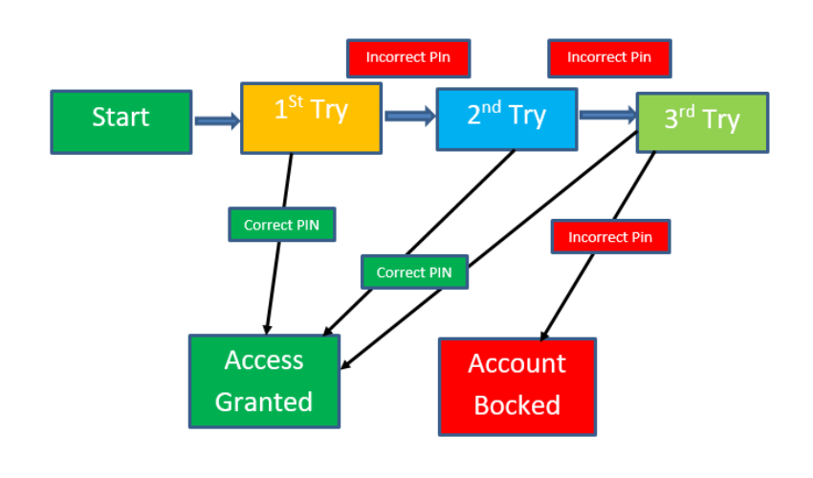
Conclusion
The state changes based on the user's actions. After three failed attempts, the account moves to Locked and requires successful OTP verification to unlock.

TASK-3
Given the following use case: 'A Zomato user can place an order, cancel it before it is prepared, or track the order once prepared,' create a use case diagram and list at least 3 possible test scenarios based on it.
ANSWER:
USECASE DIAGRAM
┌─────────────────────────┐
│ Zomato App │
│ │
User ─────────────►│ Place Order │
User ─────────────►│ Cancel Order │
User ─────────────►│ Track Order │
│ │
└─────────────────────────┘
Actor: User
Use Cases:
- Place Order
- Cancel Order
- Track Order
Test Scenarios
No. | Test Scenario | Expected Result
1 | User places an order successfully. | Order should be placed and confirmation should be displayed.
2 | User cancels an order before it is prepared. | Order should be cancelled successfully.
3 | User tracks an order after it is prepared. | Current order status/location should be displayed.

Conclusion
The use case diagram shows how the user interacts with the Zomato app for placing, cancelling, and tracking an order.

TASK-4
Modify your decision table from Task 1 to include an additional rule: the coupon cannot be used more than twice by the same user. Update the table and explain how this new rule changes the possible outcomes.
Hint: Add a column for 'Coupon Usage Count' and adjust the actions accordingly.
ANSWER:
New Rule: A coupon cannot be used more than twice by the same user.
For this rule, the coupon is accepted only when:
- User is logged in
- Cart value is above ₹500
- Coupon is not expired
- Usage count is less than 2 when making the new use — so a user with 0 or 1 previous uses can use it; at 2 previous uses, it must be rejected.
Rule | Logged In? | Cart > ₹500? | Coupon Valid? | Usage Count | Action
R1 | Y | Y | Y | 0 | ✅ Accept
R2 | Y | Y | Y | 1 | ✅ Accept
R3 | Y | Y | Y | 2 | ❌ Reject
R4 | Y | Y | N | 0 | ❌ Reject
R5 | Y | N | Y | 0 | ❌ Reject
R6 | N | Y | Y | 0 | ❌ Reject
R7 | Y | N | N | 1 | ❌ Reject
R8 | N | N | N | 2 | ❌ Reject
How the new rule changes the outcomes
Previously, a coupon was accepted when the three original conditions were satisfied. Now, the system must also check the Coupon Usage Count.
For example, even if the user is logged in, the cart is above ₹500, and the coupon is valid, it will be rejected if the user has already used it twice.
Conclusion
Adding the usage-count condition makes coupon validation stricter and prevents a user from using the same coupon more than two times.

